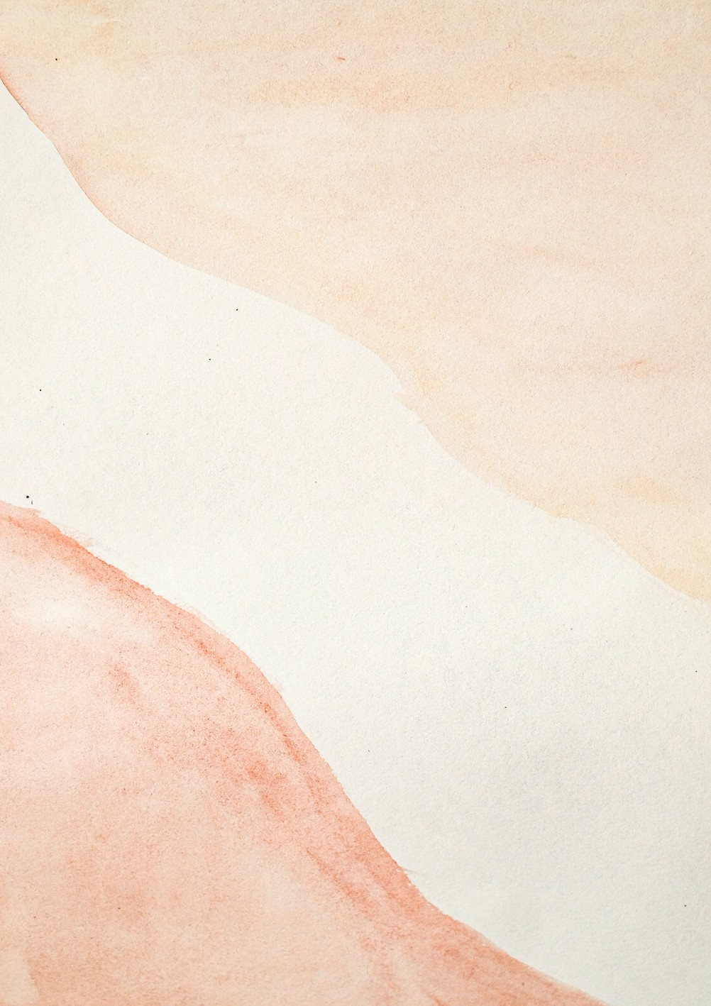Lake Michelle Homeowners Association NPC

|  |  |  |  |  |
| --- | --- | --- | --- | --- |
| **To: Spine Africa Association (Pty) Ltd** | **Date:** 29-September-2023  **Invoice#: ##-00072938Fy**  **PO # : #@_043418**  **I N V O I C E** | | |  |
| DESCRIPTION | PRICE QTY. | | | AMOUNT |
|  |  |  |  | |
| Local Courier Service | R 869.53 | 364  Total | R 6533.23  R 6533.23 | |
| Total Tax 10% |  | |
| **Grand Total** | R501601 | |
|  | | | | |